Question 1: What is the purpose of a PivotTable in Excel?
Answer:
- A PivotTable is an essential Excel tool designed to quickly summarize, analyse, explore, and present large amounts of data interactively. Its main purpose is to transform overwhelming raw data into a compact and meaningful summary report without complex formulas.
- You can drag and drop data fields (like 'Region' or 'Product') to instantly "pivot" your data, viewing it from different perspectives. PivotTables automatically calculate and aggregate data (such as sum, average, or count) for any numeric field (like 'Sales').
- This allows you to effortlessly identify patterns, trends, and comparisons, turning complex datasets into flexible reports that support fast, informed business decisions.

Question 2: Create a PivotTable to show Total Sales by Region.

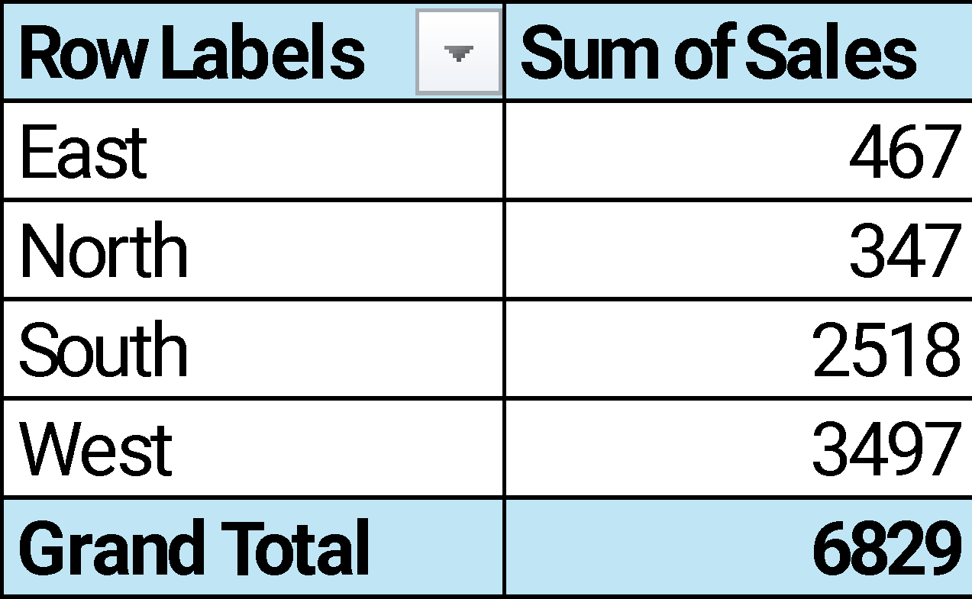
Solution :

Question 3: Conditional Formatting
Apply Conditional Formatting to highlight sales greater than 400.

Solution:
Date | Region | Product | Sales
01-01-2024 | West | Mangoes | 456
10-01-2024 | South | Oranges | 348
20-01-2024 | South | Mangoes | 247
29-01-2024 | West | Apples | 230
08-02-2024 | West | Mangoes | 281
17-02-2024 | West | Oranges | 334
27-02-2024 | South | Apples | 417
07-03-2024 | West | Apples | 441
17-03-2024 | South | Mangoes | 76
26-03-2024 | West | Oranges | 441
05-04-2024 | South | Mangoes | 205
14-04-2024 | West | Oranges | 483
24-04-2024 | East | Mangoes | 467
03-05-2024 | West | Mangoes | 380
13-05-2024 | South | Oranges | 497
22-05-2024 | South | Mangoes | 409
01-06-2024 | West | Oranges | 53
10-06-2024 | West | Apples | 398
20-06-2024 | North | Oranges | 347
30-06-2024 | South | Apples | 319

Question 4:

Explain the difference between Sorting and Filtering with an example from this dataset

Answer:
Sorting
Sorting is a function used to organize and rearrange the entire dataset based on the values in one or more columns. It changes the vertical order of all the records, but it does not remove or hide any data.
- Example: If you sort the dataset by the Quantity column from smallest to largest, the entire data table would be reordered. It would start with the lowest quantity sold (23 units for Mangoes in the South) and end with the highest (97 units for Oranges in the West and Mangoes in the East).
Filtering
Filtering is used to isolate and display only a specific subset of your data that meets a certain criterion. Unlike sorting, filtering temporarily hides all rows that do not match your criteria, reducing the number of visible rows.
- Example: If you apply a filter to the Product column and select only "Apples," the data will temporarily hide all rows for Oranges, Bananas, and Mangoes. This leaves you with only the 4 transactions where Apples were sold.

Question 5:
Create a PivotChart showing Monthly Sales Trend.
Solution:

Question 6: Slicer for Product
Use a Slicer to filter data by Product and observe changes in sales.
Solution:
Row Labels | Sum of Sales
Apples | 1805
Mangoes | 2521
Oranges | 2503
Grand Total | 6829
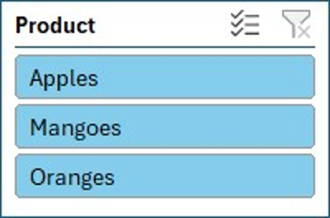

Question 7: Why are Dashboards important for decision-making in business analysis?
Answer:
Dashboards are critical for business decision-making because they transform large, complex datasets into a single, easy-to-understand visual summary. Instead of looking at thousands of rows in a spreadsheet, a leader can look at one screen and instantly understand what is happening in their business.
Their importance comes from several key benefits:
- At-a-Glance Understanding: They consolidate multiple Key Performance Indicators (KPIs) and metrics (like total sales, monthly trends, and regional performance) onto one page. This saves time and allows for quick, high-level analysis.
- Identifies Trends and Patterns: Visual charts (like line charts for trends or bar charts for comparisons) make it easy to spot patterns, outliers, and trends (e.g., "Sales are down in the West region this month").
- Informed, Faster Decisions: By presenting real-time or up-to-date information visually, dashboards help managers move from data to insight to decision much faster.
- Interactivity (Drill-Down): Modern dashboards (especially those with Slicers) are interactive. A manager can filter by "Product" or "Region" to instantly see how it affects all other charts, helping them find the reason behind a trend.
- Better Communication: They provide a clear and simple way to share performance and insights with the entire team or stakeholders, ensuring everyone is focused on the same goals.

Question 8: Dashboard Creation
Create a Dashboard that includes: Sales by Region (PivotTable + Chart), Product Filter (Slicer), Monthly Trend (Line Chart).

Solution:
- Sales by Region PivotTable and Chart for comparison

Row Labels | Sum of Sales
East | 467
North | 347
South | 2518
West | 3497
Grand Total | 6829

- Product Filter Slicer for interactive filtering
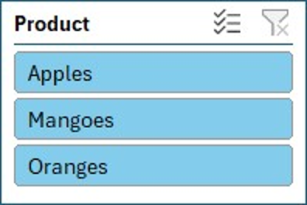
Row Labels | Sum of Sales
Apples | 1805
Mangoes | 2521
Oranges | 2503
Grand Total | 6829

- Monthly Trend Line Chart

Row Labels | Sum of Sales
Jan | 1281
Feb | 1032
Mar | 958
Apr | 1155
May | 1286
Jun | 1117
Grand Total | 6829

Question 9: Group Dates and Calculate Average
Group dates in the PivotTable into Months and calculate the average sales per month.
Solution:
Row Labels | Average of Sales
Jan | 320.25
Feb | 344.00
Mar | 319.33
Apr | 385.00
May | 428.67
Jun | 279.25
Grand Total | 341.45

Question 10: Group Products
Combine Apples and Oranges into one group called Fruits and compare its sales with other products.
Solution :

Row Labels | Sum of Sales
Fruits | 4308
Apples | 1805
Oranges | 2503
Mangoes | 2521
Grand Total | 6829

